**AIM:Design Web Applications using Client Side Session Management.**

**A) WAP to implement Client side state management techniques and Server side state management techniques on the form design attached with the assignment.**

**SERVER SIDE MANAGEMENT:**

**SOURCE CODE:**

**SM.aspx:**

<%@ Page Language="C#" AutoEventWireup="true" CodeFile="SM2.aspx.cs" Inherits="SM2" %>

<!DOCTYPE html PUBLIC "-//W3C//DTD XHTML 1.0 Transitional//EN" "http://www.w3.org/TR/xhtml1/DTD/xhtml1-transitional.dtd">

<html xmlns="http://www.w3.org/1999/xhtml">

<head runat="server">

<title></title>

</head>

<body>

<form id="form1" runat="server">

<div>

Name: <asp:Label ID="name" runat="server"></asp:Label>

<br />

Age: <asp:Label ID="age" runat="server"></asp:Label>

<br />

Branch: <asp:Label ID="branch" runat="server"></asp:Label>

<br />

</div>

</form>

</body>

</html>

**SM.aspx.cs:**

using System;

using System.Collections.Generic;

using System.Linq;

using System.Web;

using System.Web.UI;

using System.Web.UI.WebControls;

public partial class SM2 : System.Web.UI.Page

{

protected void Page_Load(object sender, EventArgs e)

{

if (Session["name"] != null)

{

name.Text = Session["name"].ToString();

}

if (Session["age"] != null)

{

age.Text = Session["age"].ToString();

}

if (Session["branch"] != null)

{

branch.Text = Session["branch"].ToString();

}

}

}

**SM2.aspx:**

<%@ Page Language="C#" AutoEventWireup="true" CodeFile="SM2.aspx.cs" Inherits="SM2" %>

<!DOCTYPE html PUBLIC "-//W3C//DTD XHTML 1.0 Transitional//EN" "http://www.w3.org/TR/xhtml1/DTD/xhtml1-transitional.dtd">

<html xmlns="http://www.w3.org/1999/xhtml">

<head runat="server">

<title></title>

</head>

<body>

<form id="form1" runat="server">

<div>

Name: <asp:Label ID="name" runat="server"></asp:Label>

<br />

Age: <asp:Label ID="age" runat="server"></asp:Label>

<br />

Branch: <asp:Label ID="branch" runat="server"></asp:Label>

<br />

</div>

</form>

</body>

</html>

**SM2.aspx.cs:**

using System;

using System.Collections.Generic;

using System.Linq;

using System.Web;

using System.Web.UI;

using System.Web.UI.WebControls;

public partial class SM2 : System.Web.UI.Page

{

protected void Page_Load(object sender, EventArgs e)

{

if (Session["name"] != null)

{

name.Text = Session["name"].ToString();

}

if (Session["age"] != null)

{

age.Text = Session["age"].ToString();

}

if (Session["branch"] != null)

{

branch.Text = Session["branch"].ToString();

}

}

}

**OUTPUT:**

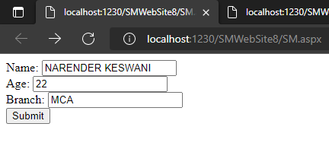

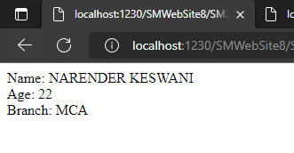

**CLIENT SIDE MANAGEMENT:**

**SOURCE CODE:**

**Cookie.aspx:**

<%@ Page Language="C#" AutoEventWireup="true" CodeFile="Cookie.aspx.cs" Inherits="Cookie" %>

<!DOCTYPE html PUBLIC "-//W3C//DTD XHTML 1.0 Transitional//EN" "http://www.w3.org/TR/xhtml1/DTD/xhtml1-transitional.dtd">

<html xmlns="http://www.w3.org/1999/xhtml">

<head runat="server">

<title></title>

</head>

<body>

<form id="form1" runat="server">

<div>

Name: <asp:TextBox ID="name" runat="server"></asp:TextBox>

<br />

Age: <asp:TextBox ID="age" runat="server"></asp:TextBox>

<br />

Branch: <asp:TextBox ID="branch" runat="server"></asp:TextBox>

<br />

<asp:Button ID="Button1" runat="server" OnClick="Button1_Click" Text="Submit" />

</div>

</form>

</body>

</html>

**Cookie.aspx.cs:**

using System;

using System.Collections.Generic;

using System.Linq;

using System.Web;

using System.Web.UI;

using System.Web.UI.WebControls;

public partial class Cookie : System.Web.UI.Page

{

protected void Page_Load(object sender, EventArgs e)

{

}

protected void Button1_Click(object sender, EventArgs e)

{

HttpCookie userInfo = new HttpCookie("userInfo");

userInfo["name"] = name.Text;

userInfo["age"] = age.Text;

userInfo["branch"] = branch.Text;

Response.Cookies.Add(userInfo);

Response.Redirect("C2.aspx");

}

}

**C2.aspx:**

<%@ Page Language="C#" AutoEventWireup="true" CodeFile="C2.aspx.cs" Inherits="C2" %>

<!DOCTYPE html PUBLIC "-//W3C//DTD XHTML 1.0 Transitional//EN" "http://www.w3.org/TR/xhtml1/DTD/xhtml1-transitional.dtd">

<html xmlns="http://www.w3.org/1999/xhtml">

<head runat="server">

<title></title>

</head>

<body>

<form id="form1" runat="server">

<div>

Name: <asp:Label ID="name" runat="server"></asp:Label>

<br />

Age: <asp:Label ID="age" runat="server"></asp:Label>

<br />

Branch: <asp:Label ID="branch" runat="server"></asp:Label>

<br />

</div>

</form>

</body>

</html>

**C2.aspx.cs:**

using System;

using System.Collections.Generic;

using System.Linq;

using System.Web;

using System.Web.UI;

using System.Web.UI.WebControls;

public partial class C2 : System.Web.UI.Page

{

protected void Page_Load(object sender, EventArgs e)

{

HttpCookie reqCookies = Request.Cookies["userInfo"];

if (reqCookies != null)

{

name.Text = reqCookies["name"].ToString();

age.Text = reqCookies["age"].ToString();

branch.Text = reqCookies["branch"].ToString();

}

}

}

**OUTPUT:**

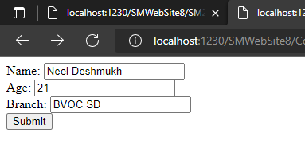

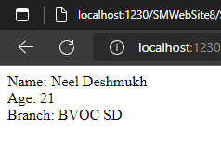

**CONCLUSION:**

From this practical, I have learned and implemented client & server side session management.